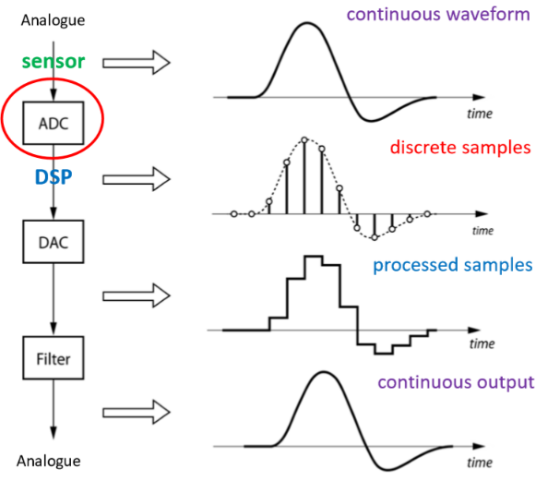**Analogue to Digital Conversion I**

**Digital Signal Processing**

Analogue to digital converter (**ADC**) Digital signal processor (**DSP**) Digital to analogue converter (**DAC**)

* Analogue = continuous
* Digital = discrete

Internal 12-bit ADC on the MCU

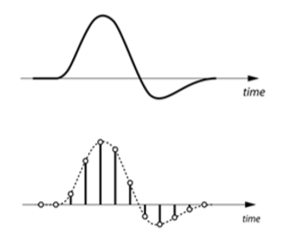**Continuous Signals vs. Digital Signals**

Continuous signals cannot be directly processed by **DSP**

* Sampling(time)**(1.1)** = continuous-time -> discrete-time
* Quantization(amplitude)**(2.1)** = continuous-amplitude -> discrete-amplitude

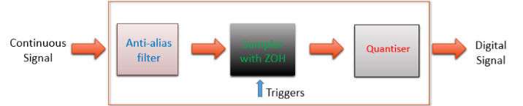**Analogue to Digital Converter (ADC**)

ZOH = zero-order-hold

1. Anti-alias filter = removes **aliased** frequencies
2. ZOH(Sampling)**(1.1)** = holds input values until triggered

ADC diagram

1. Quantiser(Quantization)**(2.1)** = maps held input values to discrete value

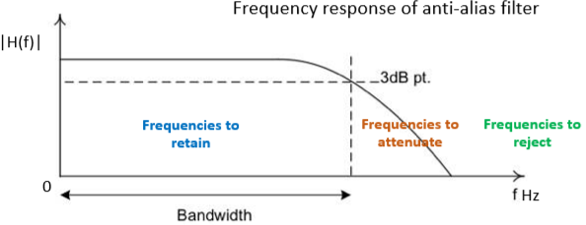

**Anti-Alias Filter** (step 1)

* Low pass filter (low frequencies pass)

**Nyquist-Shannon Sampling** **Theorem** and **Nyquist Rate** (step 2)**(1.1)**(Sampling)

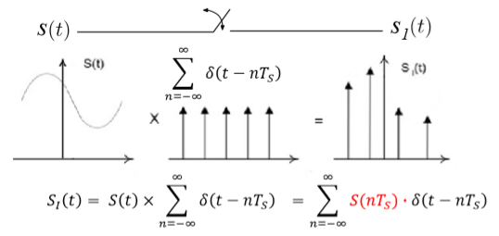Ts = sampling period fs = sampling frequency

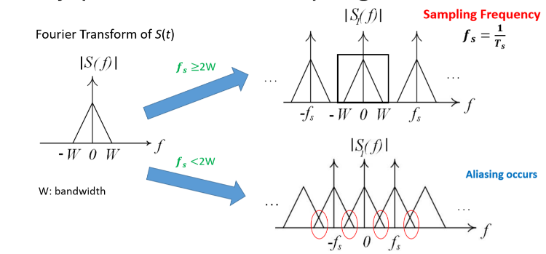fs ≥ 2W = No Aliasing fs < 2W = Aliasing occurs